Executive Summary
Modern operating systems rely on a layered, defense-in-depth security architecture to maintain the core tenants of information security: Confidentiality, Integrity, and Availability (CIA). As hardware architectures have evolved, the boundary of the security perimeter has shifted from software-only logical boundaries down to hardware-enforced cryptographic roots of trust.
This report provides an exhaustive architectural analysis of Systems & OS Internals (Level 3 Security Architecture). It dissects the mechanisms modern kernels (primarily Windows NT and Linux/Unix-like environments) use to verify identity, enforce boundaries, isolate workloads, and protect volatile and non-volatile secrets.

1. Authentication Flow
Authentication is the mechanism by which a system verifies the identity of a principal (user, process, or device) attempting to interact with resources.

1.1 Windows Authentication Architecture (LSASS & Kerberos)
The Windows authentication model relies on the Local Security Authority Subsystem Service (LSASS) (lsass.exe), a user-mode process responsible for enforcing local security policies, verifying identities, and generating access tokens.
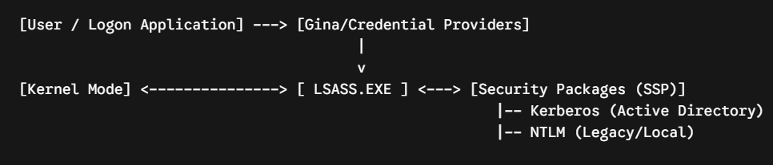
- Credential Providers: Components that capture credentials (passwords, PINs, biometrics via Windows Hello) and pass them to LSASS.
- Security Support Providers (SSPs): LSASS utilizes DLLs known as SSPs to implement specific protocols:
  - Kerberos v5: The default protocol for domain environments. It relies on a Key Distribution Center (KDC) and utilizes symmetric cryptography to issue tickets:
    - AS-REQ / AS-REP: The client requests a Ticket Granting Ticket (TGT) from the Authentication Service (AS).
    - TGS-REQ / TGS-REP: The client presents the TGT to the Ticket Granting Service (TGS) to request a Service Ticket (ST) for a target resource.
  - NTLM: A legacy challenge-response protocol used for local authentication or when a KDC is unavailable. It is susceptible to relay attacks and is systematically being phased out.

1.2 Linux Authentication Architecture (PAM)
Linux utilizes Pluggable Authentication Modules (PAM), a highly modular framework that decouples application development from underlying authentication technologies.
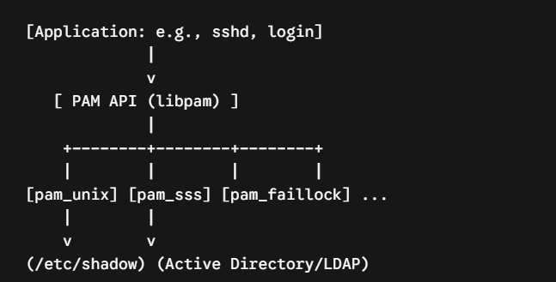
PAM configurations are defined per-service (typically in /etc/pam.d/) and execute modules sequentially through four management groups:
- auth: Establishes user identity (e.g., verifying a password against /etc/shadow via pam_unix.so).
- account: Verifies whether the authenticated account is valid (e.g., checking expiration dates, time-of-day restrictions).
- password: Manages the updating of authentication tokens (e.g., enforcing password complexity via pam_pwquality.so).
- session: Configures the environment before granting access and cleans up after exit (e.g., mounting home directories, logging via pam_selinux.so).

2. Authorization Models
Once a principal is authenticated, the operating system must determine what actions that principal can perform on a given resource (object).

2.1 Discretionary Access Control (DAC)
DAC allows the owner of an object to govern access permissions at their own discretion.

Windows DAC (ACLs and ACEs)
In Windows, every securable object features a Security Descriptor containing a Discretionary Access Control List (DACL).
- A DACL consists of an ordered array of Access Control Entries (ACEs).
- Each ACE specifies a Security Identifier (SID) and an access mask (e.g., GENERIC_READ, DELETE).
- Evaluation Order: The Security Reference Monitor (SRM) evaluates ACEs sequentially. It stops at the first explicit Deny that matches the requester's SIDs, or when all requested permissions are satisfied by explicit Allow entries. If the DACL is empty, access is denied. If the object lacks a DACL entirely, access is granted to everyone.

Linux DAC (POSIX Permissions)
Traditional Linux uses a simpler, bitmask-based approach assigned to three categories: Owner (User), Group, and Others.
- Permissions are represented by 9 bits: Read ($r=4$), Write ($w=2$), and Execute ($x=1$), duplicated across the three categories (e.g., rwxr-xr-x or octal 755).
- Special Bits:
  - SetUID (SUID - 4000): Executes the file with the privileges of the file owner.
  - SetGID (SGID - 2000): Executes with the privileges of the file's group, or inherits directory group ownership.
  - Sticky Bit (1000): Restricts file deletion within a directory to the file's owner or root.

2.2 Mandatory Access Control (MAC)
MAC enforces system-wide security policies regardless of the object owner's preferences. It is primarily used to prevent privilege escalation and contain compromised applications.

SELinux (Security-Enhanced Linux)
Developed by the NSA, SELinux implements a Type Enforcement (TE) model. Every process (subject) runs within a defined domain, and every object (file, socket) is labeled with a type.
- Security Context Syntax: user:role:type:sensitivity
- Policy Enforcement: Unless a specific allow rule exists in the active policy compiled into the kernel (e.g., allow httpd_t httpd_sys_content_t:file read;), the operation is rejected, even if the process runs as root ($UID=0$).

AppArmor
AppArmor is an alternative Linux MAC provider that is path-based rather than label-based. Security profiles are applied directly to executable paths (e.g., /usr/sbin/ntpd), defining explicit file permissions, network capabilities, and raw socket access. It is simpler to configure than SELinux but less granular.

3. Privilege Models
Operating systems govern administrative power through privilege models to minimize the blast radius of executing code.

3.1 Windows Privileges and Rights
Windows distinguishes between group memberships (which control object access) and privileges/user rights (which control system-wide tasks).
- Privileges: Granted via the local security policy and attached to access tokens. Examples include:
  - SeBackupPrivilege: Bypasses file ACLs to back up files.
  - SeDebugPrivilege: Allows a process to attach a debugger to any process, including kernel-level or LSASS components (a high-value target for credential dumping).
  - SeImpersonatePrivilege: Enables a service to impersonate a client process after authentication.

3.2 Linux Capabilities
To eliminate the inherent risk of monolithic root privileges ($UID=0$), modern Linux kernels split traditional root powers into discrete, independent units called Capabilities. This allows a process to perform a single administrative action without running with full root authority.

Capability | Description
CAP_NET_ADMIN | Perform network configuration tasks (routing, firewall, interface manipulation).
CAP_NET_BIND_SERVICE | Bind a socket to privileged internet domain ports (ports < 1024).
CAP_SYS_ADMIN | A broad capability ("the new root"); permits mounting, chroot, and IPC config.
CAP_SYS_PTRACE | Trace or debug arbitrary processes using ptrace(2).
Capabilities are assigned to files using extended file attributes (security.capability) and are evaluated via sets: Permitted, Inheritable, and Effective.

4. Access Tokens
An access token is an internal kernel object that describes the security context of a process or thread.

4.1 Windows Access Token Internals
When a user logs on, the system verifies credentials and creates a primary access token. Every process spawned by that user inherits a copy of this token.
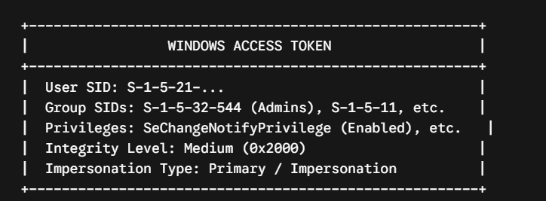
- Token Impersonation: A thread can adopt a different access token (an impersonation token) to perform operations on behalf of a client. Impersonation levels dictate how far the server can go:
  - Anonymous: Server cannot discover client identity.
  - Identification: Server can verify identity but cannot access objects.
  - Impersonation: Server can act as the client locally.
  - Delegation: Server can impersonate the client across network boundaries (requires Kerberos delegation configuration).

4.2 Linux Process Credentials
In Linux, process identity is tracked inside the kernel within the task descriptor (struct task_struct) via the cred structure. It contains:
- Real UID (RUID): Identifies the actual owner of the process.
- Effective UID (EUID): Used by the kernel for resource access checks (altered via SUID binaries).
- Saved UID (SUID): Stores the previous EUID during state changes, allowing a privileged process to temporarily drop and reclaim privileges.
- FileSystem UID (FSUID): Used exclusively for filesystem access checks; usually matches the EUID.

5. User Account Control (UAC)
User Account Control (UAC) is a Windows defense mechanism designed to mitigate the risks of administrative users running with elevated rights continuously.

5.1 Split-Token Architecture
When an administrative user logs into a UAC-enabled system, LSASS creates two distinct access tokens:
- Filtered (Standard User) Token: Strips out administrative SIDs (e.g., changes Builtin\Administrators to a group with deny-only attributes) and disables powerful privileges (like SeDebugPrivilege).
- Elevated (Full Administrator) Token: Retains all administrative privileges and group memberships.
All desktop applications (explorer.exe) launch using the filtered token. When an administrative task is initiated, the application requests elevation.

5.2 The Elevation Mechanism
- Trigger: An executable manifests an elevation requirement (via an embedded XML manifest <requestedExecutionLevel level="requireAdministrator"/>) or triggers installer detection heuristics.
- RPC Call: The system issues an RPC call to the Application Information Service (Appinfo).
- Consent Prompt: Appinfo spawns consent.exe inside a secure desktop environment (isolated from the standard user desktop to prevent programmatic UI spoofing).
- Token Assignment: If approved, Appinfo creates the target process utilizing the full administrative token.

6. Sandboxing
Sandboxing limits the damage an application can cause by restricting its access to files, network devices, and other processes.

6.1 Windows AppContainer
The AppContainer isolation environment provides an explicit security boundary for Modern Windows Apps (UWP) and sandboxed desktop software (e.g., web browser tabs).
- Low Privilege Levels: AppContainers operate at an integrity level below "Low" (termed AppContainer Integrity).
- Capability-Based Access: Standard DAC/MAC checks deny an AppContainer access to user data by default. The container must have explicitly declared capabilities (e.g., internetClient, picturesLibrary) matching the security attributes applied to directories and resources.
- Siloed Object Namespace: They run inside an isolated object namespace, preventing unauthorized IPC with processes on the main desktop.

6.2 Linux Namespaces and Cgroups
The foundation of modern Linux containerization (Docker, Podman) and sandboxing architectures depends directly on two fundamental kernel primitives:

Namespaces (Virtualizing System Resources)
Namespaces restrict what a process can see. The kernel exposes several distinct types:
Namespace | Isolates
pid | Process IDs (the sandboxed process becomes PID 1 inside its scope).
net | Network devices, IP routing tables, port bindings, and firewall rules.
mnt | Filesystem mount points (paired with chroot or pivot_root).
ipc | System V IPC and POSIX message queues.
uts | Hostnames and NIS domain names.
user | Maps root inside the namespace to an unprivileged UID outside.

Control Groups (Cgroups)
While namespaces control visibility, Cgroups control resource consumption. They prevent Denial-of-Service (DoS) vectors by metering and limiting hardware resources:
- CPU: Assigns relative shares or strict execution periods.
- Memory: Caps physical RAM and swap space usage.
- BlkIO: Imposes strict read/write throttling on block storage devices.

7. Secure Boot
Secure Boot establishes a cryptographically validated chain of custody from hardware initialization up to the execution of user-space components.
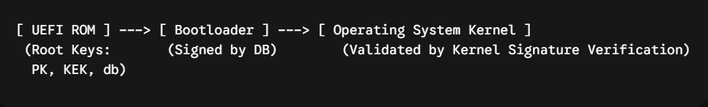

7.1 The Cryptographic Chain of Trust
- Platform Key (PK): Established by the hardware OEM. It governs ownership of the platform and controls updates to the Key Exchange Key database.
- Key Exchange Key (KEK): Contains certificates authorized to modify the signature databases (db and dbx). Typically includes Microsoft and operating system vendor public keys.
- Signature Database (db): Contains public keys and hashes of authorized boot loaders, drivers, and option ROMs allowed to execute on the machine.
- Forbidden Signature Database (dbx): A cryptographic blacklist containing compromised certificates or hashes of known vulnerable binaries. If an artifact matches an entry in dbx, execution is immediately halted.
During initialization, the UEFI firmware verifies the signature of the primary bootloader (e.g., Windows Boot Manager or Linux shim) using keys in the db database. The bootloader subsequently verifies the OS kernel, creating an unbroken chain of trust.

8. Trusted Platform Module (TPM)
The TPM is a tamper-resistant microcontroller designed to perform hardware-level cryptographic operations and securely store keys.

8.1 Measured Boot and PCRs
Unlike Secure Boot (which enforces an execution policy based on signatures), Measured Boot measures the cryptographic hash of each component before it executes and records that measurement into Platform Configuration Registers (PCRs).
- PCR Extend Operation: To prevent arbitrary value spoofing, PCRs cannot be overwritten directly. They can only be modified via an Extend operation:
- 
- PCR Layout:
  - PCR 0: SRTM (Static Root of Trust for Measurement), Motherboard Core Firmware.
  - PCR 4: Boot Loader Verification.
  - PCR 7: Secure Boot State configuration.
  - PCR 11: BitLocker/OS binding parameters.

8.2 Sealed Storage & Attestation
- Sealing: Encryption keys (such as BitLocker volume master keys) can be "sealed" to specific PCR states. If a rootkit alters the boot sequence or if Secure Boot is disabled, the resulting PCR values will change, causing the TPM to refuse to unseal the decryption key.
- Remote Attestation: The TPM utilizes an Attestation Identity Key (AIK) to sign its current PCR configuration. This cryptographic proof can be transmitted to an external verification service to prove that the endpoint booted into a verified, uncompromised state.

9. Credential Storage
Operating systems store persistent user credentials locally using robust hashing configurations to resist offline brute-force cracking.

9.1 Windows SAM and Active Directory NTDS.dit
- SAM Database: For local accounts, Windows hashes passwords using the NTLM hash function ($MD4(\text{UTF-16LE}(\text{password})))$. This data is stored within the Security Accounts Manager Registry hive (HKLM\SAM).
- NTDS.dit: Active Directory domains maintain credentials within an active directory database file located at %SystemRoot%\NTDS\ntds.dit.
- Syskey / Boot Key Protection: The hashes inside the SAM or NTDS.dit are obfuscated using a secondary wrapper key called the Boot Key (or Syskey), stored inside the System registry hive (HKLM\SYSTEM). To dump credentials offline, an attacker requires both files.

9.2 Linux Shadow Password Organization
Linux offloads user passwords from the globally readable /etc/passwd file to the restricted /etc/shadow file (readable only by root).
Modern Linux systems use highly iterative, memory-hard key derivation functions rather than standard fast hashes. The format follows an explicit multi-part layout:
$$\texttt{\$id\$salt\$hashed}$$
- $1$: MD5 (Deprecated)
- $5$: SHA-256
- $6$: SHA-512
- $y$: yescrypt (The current default in modern enterprise distributions; memory-hard, highly resistant to GPU/ASIC acceleration platforms).

10. Secret Storage
Runtime secrets—such as API tokens, private keys, and application configurations—must be safeguarded against unauthorized extraction via user-space memory access APIs.

10.1 Windows DPAPI
The Data Protection API (DPAPI) provides system-level and user-level cryptographic isolation routines without requiring the application to manage the underlying master keys.
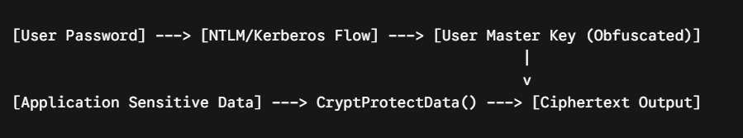
- CryptProtectData: Accepting plaintext, DPAPI encrypts the data using a master key tied directly to the current user's login password. The system handles key rotation and memory lifecycle automatically.
- Isolation: A system-level call uses a key bound to the local computer hardware configuration, whereas user-level execution relies on a user master key derived via PBKDF2 from the user's password.

10.2 Linux Secret Storage Architecture
Linux systems lack a uniform kernel-integrated user secret engine analogous to DPAPI. Instead, they implement secret isolation via discrete APIs:
- Linux Kernel Keyring: A kernel-space subsystem (keyctl) that allows applications to store cryptographic keys inside kernel memory. Permissions are handled via standard security contexts, shielding the keys from standard user-space process memory analysis tools.
- D-Bus Secret Service API: Desktop systems (via GNOME Keyring or KDE Wallet) implement a user-space daemon that communicates over D-Bus. Secrets are encrypted using a master key unlocked during login via the pam_gnome_keyring.so module and stored inside an encrypted database.

11. Process Isolation
Process isolation guarantees that one executing workspace cannot interfere with, read, or modify the states of another.

11.1 Virtual Memory Mapping
The physical RAM architecture is decoupled from user processes through Virtual Memory Managers (VMM). Each process operates under the illusion that it owns an entirely continuous, isolated address space.
- Page Tables: The translation between virtual memory addresses and actual physical memory chips is handled via nested multi-level Page Tables managed directly by the Memory Management Unit (MMU) of the processor.
- Separation: A process cannot point to a virtual address mapped to another application's physical space unless a shared-memory region has been explicitly configured.

11.2 Ring Architecture
Hardware execution rings enforce boundaries between user applications and the core operating system kernel.
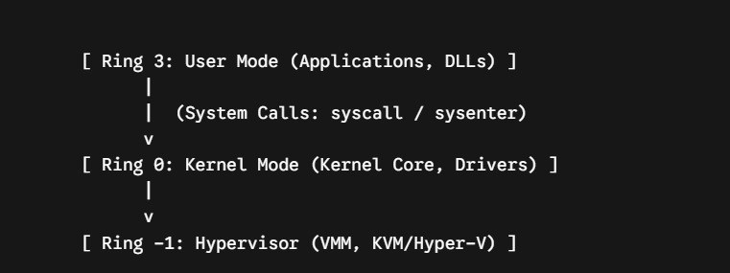
- Ring 3 (User Mode): Code has limited hardware execution powers. It cannot interact directly with physical devices or modify memory pages mapped outside its process perimeter.
- Ring 0 (Kernel Mode): Code possesses raw execution velocity and can access all hardware components and registers. Transitions from Ring 3 to Ring 0 are strictly governed by hardware-level exceptions (System Calls via syscall / sysenter).

11.3 Virtualization-Based Security (VBS)
Windows leverages the Hyper-V hypervisor to implement Virtualization-Based Security (VBS). This creates an isolated virtual space separate from the primary OS kernel.
- Virtual Trust Levels (VTL): VBS introduces independent trust domains:
  - VTL 0 (Normal World): Houses the standard Windows kernel, drivers, and user applications. Even if an exploit grants full Ring 0 access within VTL 0, it cannot breach VTL 1.
  - VTL 1 (Secure World): Houses isolated security components like Credential Guard (LsaIso.exe). Critical authentication processes run here, ensuring that credential hashes cannot be extracted from VTL 0 memory pools.

12. Memory Protection
Memory protections mitigate binary exploitation patterns (such as buffer overflows and Return-Oriented Programming) by preventing execution from arbitrary locations and randomizing process structures.

12.1 DEP / NX (Data Execution Prevention)
Historically, attackers injected shellcode into buffers (like the stack) and redirected execution to it. Data Execution Prevention (DEP)—implemented at the hardware level as the No-Execute (NX) or Enhanced Prevention (XD) bit—marks data-centric memory pages as non-executable.
- Page Allocation Flags: Memory segments allocated via APIs (e.g., VirtualAlloc in Windows or mmap in Linux) must state their exact requirements.
- Enforcement: If a memory page is marked as PAGE_READWRITE or lacking execution permissions, any attempt by the instruction pointer register to execute instructions inside that page triggers an immediate hardware-level access violation trap, terminating the offending application.

12.2 ASLR (Address Space Layout Randomization)
To prevent reliable exploitation via static memory addresses, Address Space Layout Randomization (ASLR) randomizes the location of key structures within a process's memory space during execution.
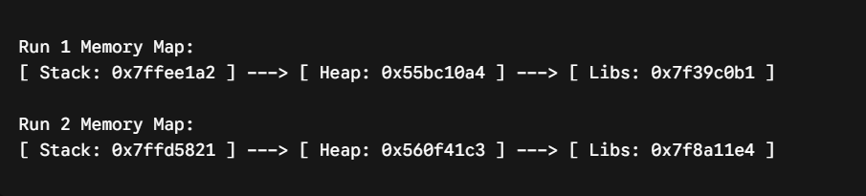
Every time an application launches, the base locations of the Executable Image, the Stack, the Heap, and individual Shared Libraries are dynamically shifted. This prevents attackers from hardcoding target jump locations (e.g., returning into libc functions or standard return gadgets).

12.3 Kernel-Specific Mitigations
As exploitation techniques have adapted to bypass user-mode defenses, modern operating system kernels enforce advanced memory safeguards within Ring 0 itself:
- SMEP (Supervisor Mode Execution Prevention): A hardware feature that blocks the kernel (Ring 0) from executing code stored inside user-space memory pages (Ring 3). This stops local privilege escalation attacks where an attacker tricks the kernel into running shellcode mapped in a standard user process.
- SMAP (Supervisor Mode Access Prevention): Complements SMEP by blocking the kernel from even reading or writing data located inside user-space pages unless explicitly allowed via designated CPU instructions.
- KASLR (Kernel Address Space Layout Randomization): Randomizes the base address of the kernel code segment in memory at boot time, preventing attackers from predicting the locations of core kernel symbols and gadget streams.

13. Deep Comparative Architecture Matrix
Architectural Security Vector | Microsoft Windows NT Architecture | Linux / Unix Architecture
Core Authentication Engine | Local Security Authority Subsystem Service (LSASS) via modular SSP subsystems. | Pluggable Authentication Modules (PAM) utilizing configurable shared library structures.
Primary Directory Auth Protocol | Kerberos v5 featuring automated local Ticket-Granting Services (TGS). | OpenLDAP / SSSD integration hooks mapped to global identity models.
Native Authorization Core | Discretionary Access Control Lists (DACLs) comprising explicit ordered Allow/Deny ACE entries. | Standard POSIX user/group/other bitwise permission mappings and POSIX ACL extensions.
Mandatory Access Control (MAC) | Windows Integrity Mechanism (Low, Medium, High, System, Protected Process). | LSM Framework implementations: SELinux (Type Enforcement) or AppArmor (Path Profiles).
Privilege Distribution Design | Explicit User Privileges and User Rights Assignments managed via Access Tokens. | Linux Capabilities Matrix (e.g., CAP_NET_BIND_SERVICE, CAP_SYS_ADMIN).
Runtime Process Identity Representation | Windows Access Token Objects containing User SIDs, Group SIDs, and Privileged Arrays. | Kernel Credential Structures (cred) monitoring RUID, EUID, SUID, and FSUID properties.
Administrative Privilege Elevation | User Account Control (UAC) running Split-Token environments with Secure Desktop context prompts. | Elevation via the SUID bit on binary execution targets, or explicitly managed policy frameworks (sudo).
Hardware Core Root of Trust Integration | Secure Boot Key Arrays (PK, KEK, db, dbx) coupled with BitLocker Sealed TPM PCR structures. | Secure Boot chains paired with independent Linux Unified Key Setup (LUKS) TPM management routines.
Kernel Memory Boundary Protections | Virtualization-Based Security (VBS) enforcing Hypervisor-level code integrity isolation (HVCI). | Hardware Page Mappings utilizing kernel-level SMEP, SMAP, and continuous KASLR sweeps.

